Movement through cell membranes

Molecules move through cell membranes by one of three methods. Diffusion, Active transport or Osmosis.

Diffusion
Diffusion is the passive random movement of molecules or particles in a liquid or gas from a region in which they are in higher concentration to regions of lower concentration. Raising the temperature increase the rate of diffusion.
Examples of diffusion.
- Gas exchange at the alveoli in the lungs — oxygen from air to blood, carbon dioxide from blood to air.
- Gas exchange at the leaves during photosynthesis — carbon dioxide from air to leaf, oxygen from leaf to air.
- Gas exchange at the capillaries for respiration — oxygen from blood to tissue cells, carbon dioxide in opposite direction.
Active transport
Active transport is the energy demanding transfer of a substance across a cell membrane against its concentration gradient, i.e., from a region where the substance is in lower concentration to where it is in higher concentration.
Examples of active transport.
- Re-absorption of glucose, amino acids and salts in the kidney.
- The absorption of mineral such as nitrates by plant roots.

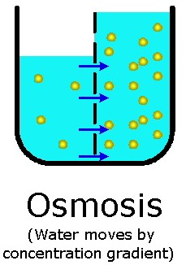
Osmosis
Osmosis is the movement of water across a semi permeable membrane from a more dilute solution to a more concentrated solution.
Examples of osmosis
- Absorption of water by plant roots. Absorption of water by seeds for germination.
- Re-absorption of water in the kidney.
- Opening and closing of the stomata due to the change in shape of guard cells brought about by osmosis.
- Absorption of water by the alimentary canal — stomach, small intestine and in particular the colon.

Osmosis and animal cells
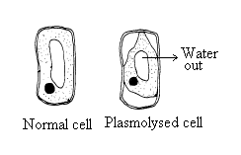Lysis is the bursting of animal cells due to the excessive uptake of water by osmosis.
Cell membranes are not strong and are not elastic - they will not stretch, so they rupture.
Crenation is the shrinkage of animal cells such as red blood cells, due to the loss of water by osmosis to a more concentrated external solution.

Osmosis and plant cells
Plasmolysis: the shrinkage of the cell contents away from the cell wall due to the loss of water by osmosis to an external solution of higher concentration. The shrinkage stops when the vacuole cell sap is at the same concentration of the external solution. Plasmolysis causes wilting

Turgor pressure
Turgor: the swollen rigid state of a plant cells due to the pressure of the cell membrane and contents against the cell wall - the force is generated by the difference in concentration between the cell sap (in vacuole) and the external solution. Turgor supplies support for soft non-woody tissue. A drop in turgor pressure when a plant loses water causes wilting.

Osmoregulation
Osmoregulation is the name give to maintaining the correct concentration of cell cytoplasm or blood. Animal cells can only function efficiently if they are surrounded by a solution of a particular concentration. The kidneys are the osmoregulatory organs in the human body maintaining the blood at the correct concentration. In freshwater amoeba a contractile vacuole is used to expel the excess water from its cytoplasm

Food preservation.
Plasmolysis is used in food preservation. Water is withdrawn by osmosis from bacteria and fungi inhibiting their growth and preventing their reproduction. High salt concentration is used in the preservation of fish or meat.

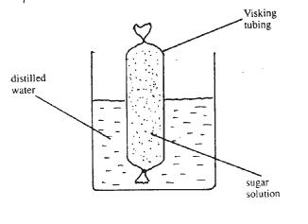
Practical Activities to demonstrae osmosis

Method 1-Using visking tubing

Tie a knot at one end of a short length of visking tubing.
Half fill the tubing with a strong glucose solution.
Tie a knot to seal the open end.
Place the visking tubing bag containing glucose into a beaker of pure water.
Allow to stand for 30 minutes to one hour.
The tubing fills and expands showing water has entered the visking tubing bag by osmosis.

Method 2 -Using Potato halves.

Scoop a hollow in a potato half and fill with salt. Place the potato half in a dish of water. Leave for a few hours. A concentration gradient or difference between the salt and water forms in the cells of the potato, which allows water to move up and into the hollow by osmosis. Repeat with a boiled potato. The water does not move up because the cell membranes are destroyed. As a control use a potato half with no salt in the hollow. Since no concentration gradient exists, no osmosis occurs.
